**Creating dashboards – to get you started**

Task 1:

Install the packaged application – sample reporting. Look through the types of reports and types of output and examples of SQL. Note useful ‘reports’ you could use.

Task 2: Look at sample application – dashboard and reports.

Look at the code, maybe change code, get more ideas of ‘reports’ you might like to create.

Task 3: Create your own dashboard.

The latest version of Apex has a dashboard page you can select. Create an application, add a page.

Select the dashboard page and choose a template (any)

Run the application it looks a bit like this:

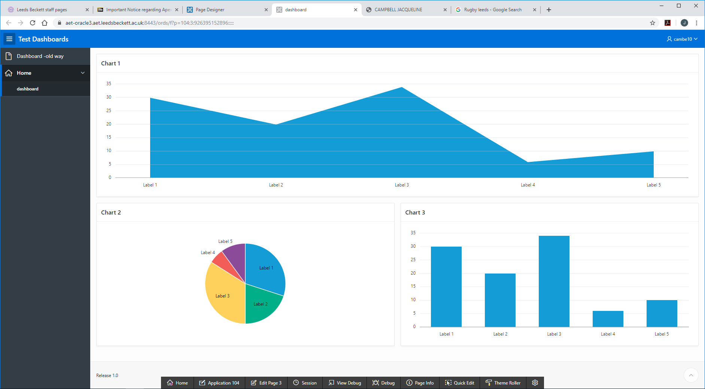

But this is not linking to any data!

**Classic Report**

Select Chart 1, go to the Source on the right and change chart – to classic report, to local database, SQL Query and SELECT * FROM emp

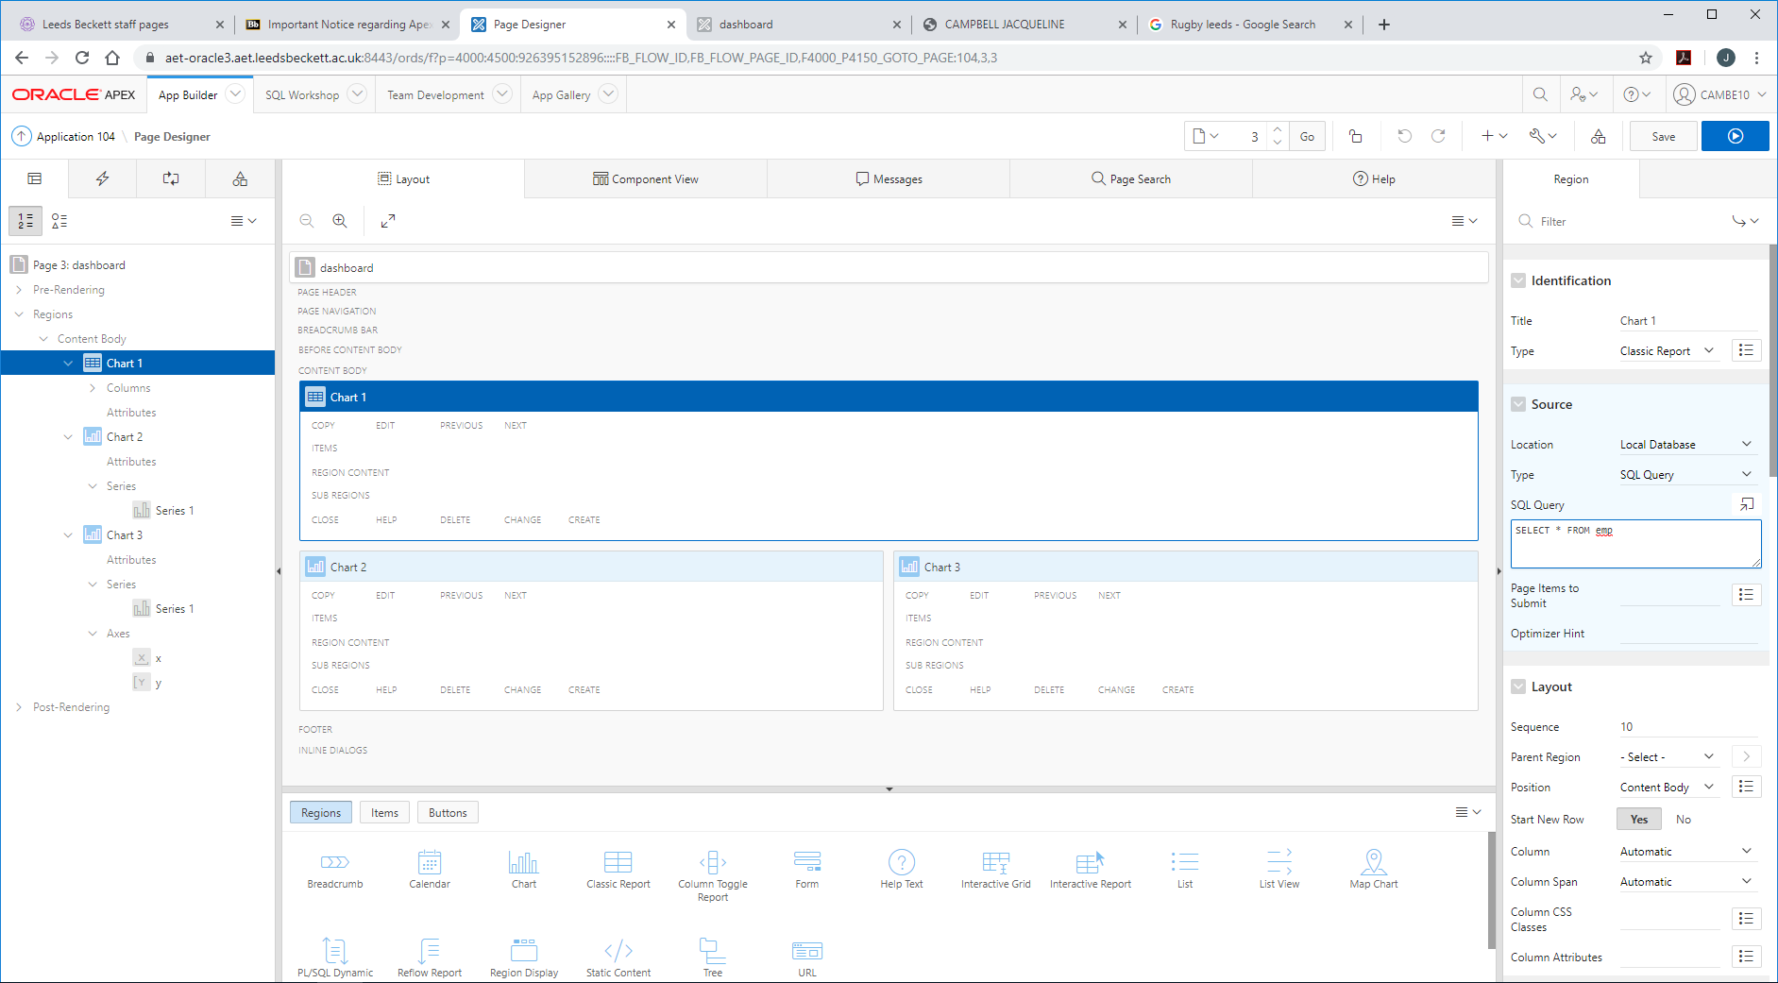

Run again.

**Bar Chart**

Edit again for chart 2, select Report – source type, select chart type and add the SQL behind the report eg:

SELECT dept.dname label,

COUNT(emp.empno) "Employees"

FROM

emp, dept WHERE emp.deptno = dept.deptno

GROUP BY dept.dname

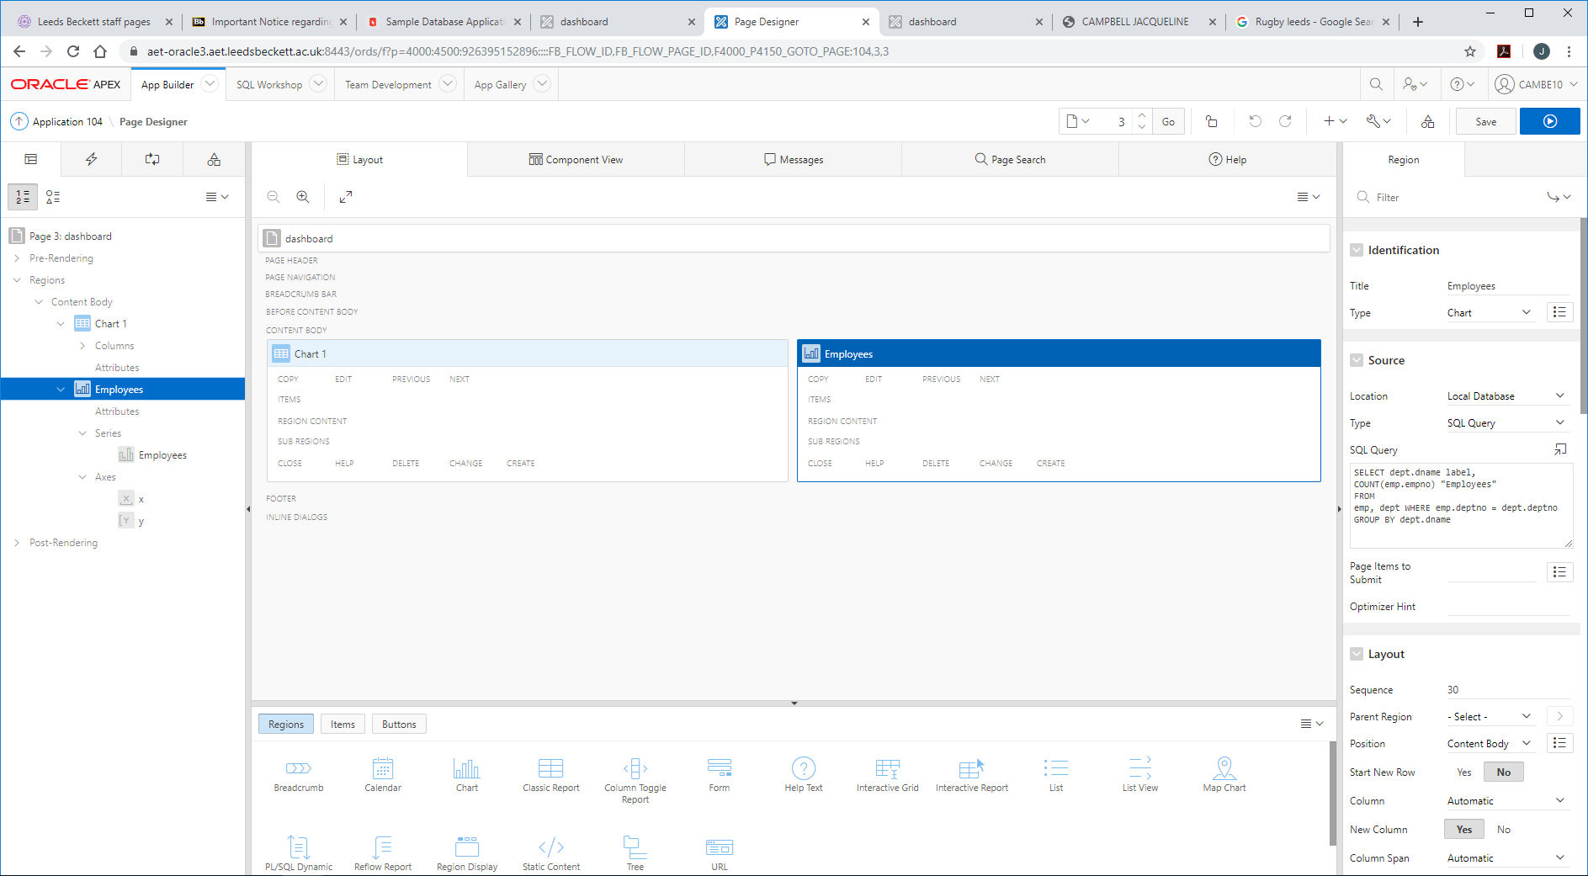

Now click on the Series and edit it – name it employees

Add local database, the SQL query

Change the column mappings to label and value – employees

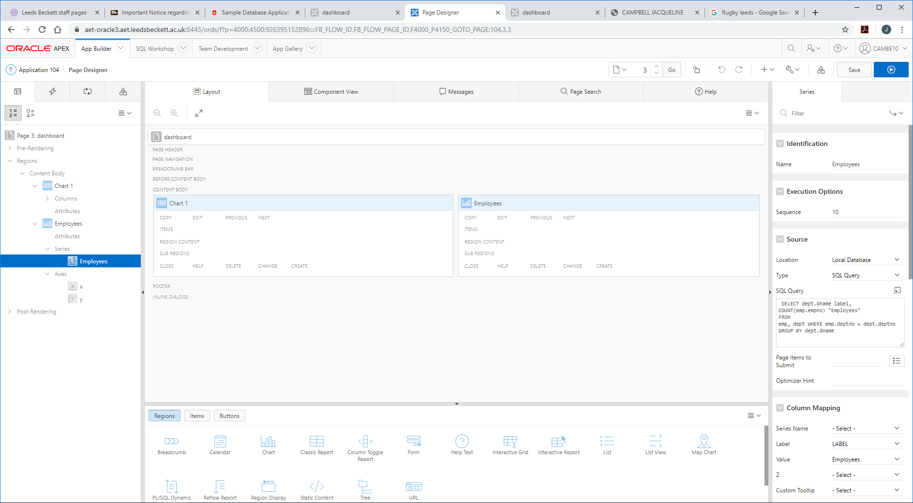

Now run it and it should look like:

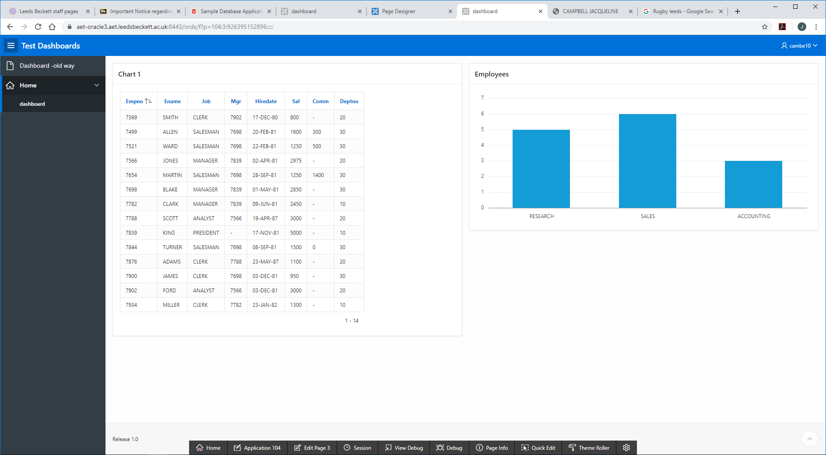

**Bar Chart 2**

Repeat the above using this SQL

select m.ename , count(e.empno) employees_for_the_mgr

from emp e, emp m

where e.mgr = m.empno

group by m.ename

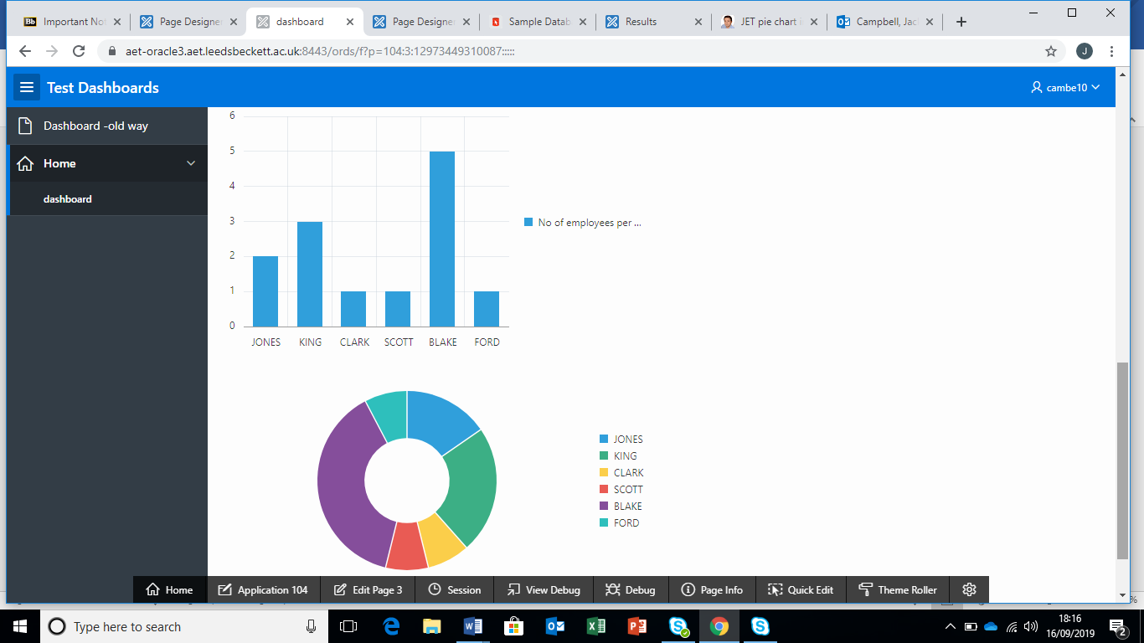

**Pie Chart/Donut**

Duplicate the above and then edit.

Click on Attributes on the left under the chart name. Select chart type to be ‘donut’ (or pie chart)

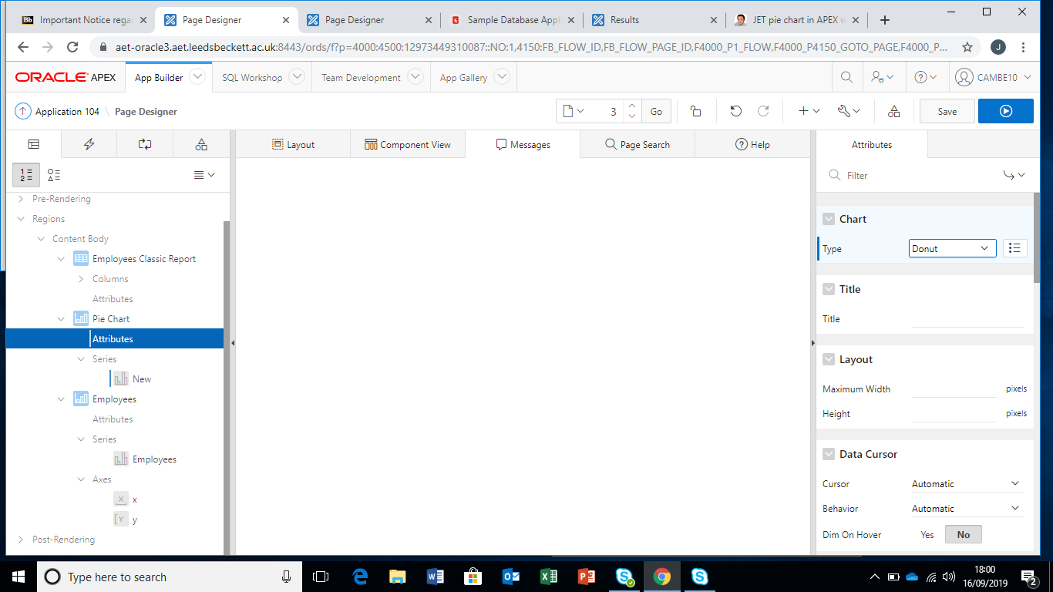

Run again.



Now – play around. With – the report source, the type of SQL, type of report (under application). Tidy it all up!

Create a dashboard!

Self study - challenge

1. Add a text field on the page, and use the input from this in the report (SQL query)
2. Pick up the user id from the page, use this in a report (SQL query). You may need to amend data, columns to do this.

Consider how this could then be used to personalise the view (dashboard) each person sees as they log in.